**SQL- Case Study**

“Richard’s Supply” is a company which deals with different food products. The company is associated with pool of suppliers. Every Supplier supplies different type of food products to Richard’s supply. This company also receives orders for the food products from various customers. Each order may have multiple products mentioned along with the quantity. The company is maintaining the database for 2 years.

Refer to the following Entity-Relationship diagram of the database.

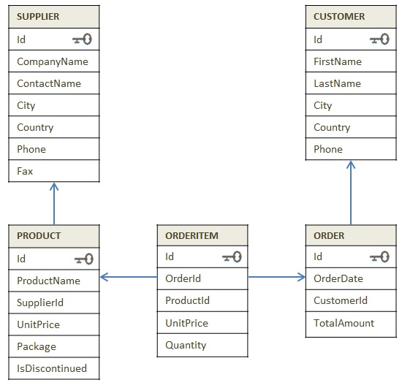

Diagram: E-R Diagram of Supply_chain database

Try to get insight of business through the dataset

**Instruction:** Execute the SQL files in the sequence given below.

1. 1_DDL_Case Study
2. 2_Data
3. 3_Data Constraints

**Section A --> Know your data Time: 45 min**

1. Read the data from all tables.
2. Find the country wise count of customers.
3. Display the products which are not discontinued.
4. Display the list of companies along with the product name that they are supplying.
5. Display customer's information who stays in 'Mexico'
6. Display the costliest item that is ordered by the customer.
7. Display supplier id who owns highest number of products.
8. Display month wise and year wise count of the orders placed.
9. Which country has maximum suppliers.
10. Which customers did not place any order.

**Section B --> Know the business Time: 60 min.**

1. Arrange the product id, product name based on high demand by the customer.
2. Display the number of orders delivered every year.
3. Calculate year-wise total revenue.
4. Display the customer details whose order amount is maximum including his past orders.
5. Display total amount ordered by each customer from high to low.

A sales and marketing department of this company wants to find out how frequently customer have business with them. This can be done in two ways. (Answer Q 6 and Q 7 for the same)

1. Approach 1. List the current and previous order amount for each customers.
2. Approach 2. List the current and previous order amount for each customers.
3. Find out top 3 suppliers in terms of revenue generated by their products.
4. Display latest order date (should not be same as first order date) of all the customers with customer details.
5. Display the product name and supplier name for each order

**Section C --> Business Analysis Time: 60 min.**

1. Fetch the records to display the customer details who ordered more than 10 products in the single order
2. Display all the product details with the ordered quantity size as 1.
3. Display the compan(y)ies which supplies products whose cost is above 100.
4. Create a combined list to display customers and supplier list as per the below format.

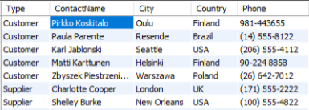

1. Display the customer list who belongs to same city and country arrange in country wise.

**Section D --> Challenge Time:60 Min.**

1. Company sells the product at different discounted rates. Refer actual product price in product table and selling price in the order item table. Write a query to find out total amount saved in each order then display the orders from highest to lowest amount saved.
2. Mr. Kavin want to become a supplier. He got the database of "Richard's Supply" for reference. Help him to pick:

a. List few products that he should choose based on demand.

b. Who will be the competitors for him for the products suggested in above questions.

1. Create a combined list to display customers and suppliers details considering the following criteria

* Both customer and supplier belong to the same country
* Customer who does not have supplier in their country
* Supplier who does not have customer in their country

1. Find out for which products, UK is dependent on other countries for the supply. List the countries which are supplying these products in the same list.